Matrix KVM over IP Console
(8 Port /16 Port/24 Port/32 Port)
User Manual

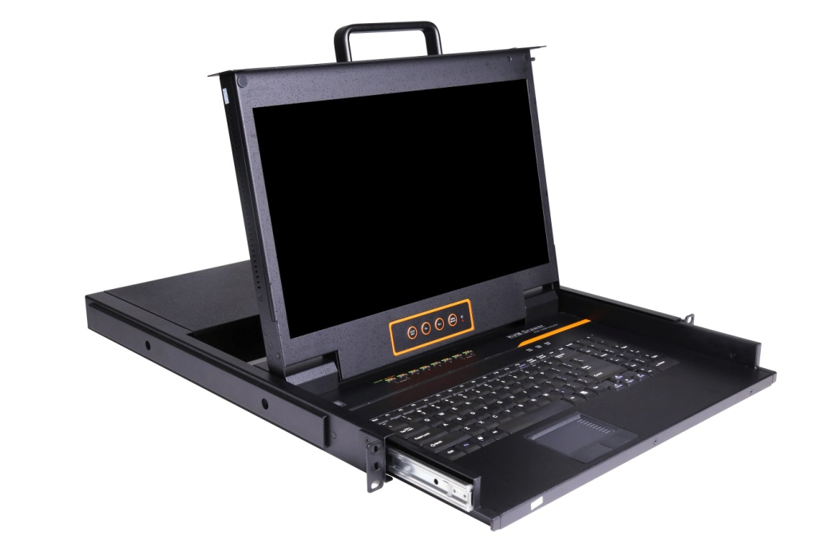

www.kinankvm.com
@all right reserved Shenzhen Kinan Technology Co., Ltd
Print date: 2024 / 05
Version: V1.7

Table of Contents
Table of Contents 1
1. Product Overview 3
1.1 Introduction 3
1.2 Features 3
1.3 Appearance 5
2. Installation and Start-up 8
2.1 Rack Mounting 8
2.2 Install KVM Components 9
2.3 KVM Adapter 10
2.4 Opening the Console 11
2.5 Closing the console 12
3. LED Operation 13
3.1 LED Functions 13
3.2 Operating the Monitor 15
3.3 Key Combination Function 16
4. User Interface Operation 17
4.1 User 18
User List 18
User group list 20
Change password 21
4.2 System 22
Network settings 22
Date time 23
Equipment information 23
Encoding parameters 24
Serial 24
4.3 Security 24
Security Settings 25
Audit log 26
4.4 Maintain 26
Backup& Restore 27
Ping 27
Update 27
5.Remote control 28
5.1 Configure the target server 28
5.2 Remote WEB interface settings 30
5.3 Log in 32
6. IP Menu Option 40
6.1 User management 40
User List 40
User group list 43
Change Password 45
6.2 System 45
Network Setting 46
Date /Time setting 47
Encoding Parameters 47
6.3 Safety management 48
Security Settings 48
Audit Log 49
6.4 System Maintenance 49
Backup& Restore 50
Ping Host 50
Equipment Management 51
Remote upgrade 51
7.Appendix 52
7.1 Specifications (17.3”) 52
7.3 Grounding Requirements 53

1. Product Overview

1.1 Introduction

The IP-based KVM (IP-KVM) redirects the local keyboard, mouse and video data to a remote management console. The operator can safely manage one or many computers locally at the server site or remotely via a standard internet browser. Securely gain BIOS level access to systems for maintenance, support or failure recovery over the internet.

The IP-KVM console integrates multiple KVM switches in a 1U height console. It can control multiple computers with a set of devices including monitor, keyboard and mouse; saving cost and space by consolidating the hardware to a single device.

The IP-KVM console is fast and easy to install. Simply connect corresponding cables to the correct ports of the KVM and its module without software configuration. Connect multiple computers with compact RJ-45 connectors and CAT5e/6/7 cables, transmitting distance is up to 100M.

1.2 Features
Hardware
- 17.3 ” LCD monitor, high definition and high resolution
- Rack-mountable in a 1U EIA system rack
- Full size keyboard with integrated number pad
- Trackball eliminates the need for a separate, external mouse
- Dual power supply

Local Console
- Control up to 8 / 16 /24/ 32 computers
- Support 1 local user and 1 remote user, port share mode allows local and remote users to gain access to a server simultaneously
- Easy-to-use switching by browser-based UI interface, hotkeys and pushbuttons
- Support servers with VGA/HDMI/DVI/DP port
- Multiplatform client support (Windows, Linux, Unix, Mac, Solaris (Sun), Redhat, Ubuntu
- Supports a graphical interface for intuitive and convenient human-computer interaction- local resolution is up to 1920 x 1080@60Hz
- Supports mouse synchronization mode-automatically synchronizes the local and remote mouse movements
- Video synchronization with local console - EDID information for local console display can be stored in the host module for video resolution optimization
- Keyboard and mouse emulation to ensure the normal booting
- Broadcast mode--operations simultaneously performed on all selected computers
- Auto scan feature for monitoring user-selected computer
- Hot pluggable – add or remove computers without having to power down the switch

Remote Console
- Adaptive 10 / 100 / 1000 Mbps network
- WEB browser-based Or KVM_Clients remote management
- BIOS-level access
- Video quality and video tolerance can be adjusted to optimize data transfer speed, up to 60 FPS
- Full screen or scalable video display
- Remote users and local users can control the same server synchronously
- Support AES / DES / 3DES encryption
- Support audit function-allows the administrator to audit the device through the system log and operation log
- Exit Macros support
- Configurable user and group permissions for server access and control
- Supports firmware upgrade

1.3 Appearance

Front View

Figure 1.1 Front view

- LED Monitor | - Rear Bracket Slot | - LED OSD Controls
- Front Bracket | - Keyboard | - Touchpad
- Handle | - Release Catch | - Display Panel
- Switch LED

Structure and Size (17.3)

Figure 1.2 17.3” console size dimensions

Rear View
Figure 1.2 Rear view

- Power Input (AC)
- Power Switch
- Power Input (DC)
- LAN Port
- USB Port
- RS485 Port
- Monitor Port
- PC Connecting Port
- Ground Screw

2. Installation and Start-up

2.1 Rack Mounting
A standard rack mounting kit is provided to mount the switch in a depth of 510-850 mm (17.3”) in a standard 19” rack. For other mounting distances, the rear brackets need to be customized accordingly. With one person hold the switch in place, the other person slides the L bracket into the switch’s side mounting brackets from the front to the back, then screws the brackets to the rack (see below installation drawing).

Figure 2.1 Rack Installation Diagram

2.2 Install KVM Components
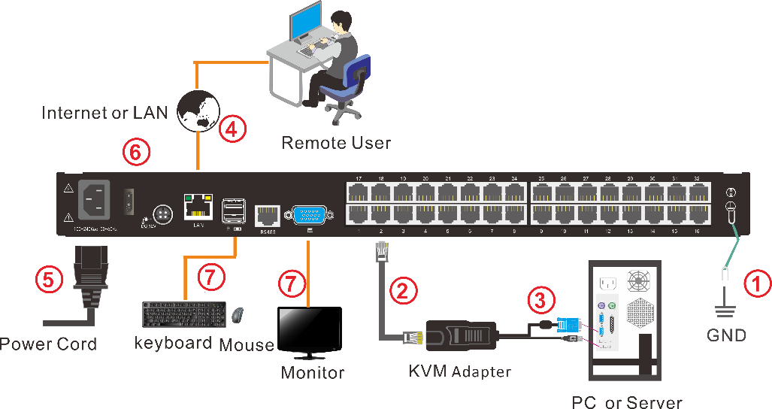
Figure 2.2 Installation diagram
Installation Steps:
  - Make sure the KVM console has been connected to the ground.
  - Connect the KVM adapter to the PC or Server.
  - Connect the KVM adapter to the KVM port with a CAT5 cable.
  - You can remote control the KVM switch via IP.
  - Using power adapter to connect the KVM into 220V AC power supply.
  - Power on the switch
  - Connect the external keyboard, mouse and monitor (optional)

2.3 KVM Adapter

PS/2 Adapter

Model No. | Keyboard/Mouse | PC | Explanation
KCM-1100P | PS/2 | VGA | Connect to PS2/VGA server

USB Adapter

Model No. | Keyboard/Mouse | PC | Explanation
KCM-1200U | USB | VGA | Connect to USB/VGA server
KCM-3200H | USB | HDMI | Connect to USB/HDMI server
KCM-2200D | USB | DVI | Connect to USB/DVI server
KCM-4200P | USB | DP | Connect to USB/DP server

Table1 : LED Indicator of the KVM Adapter

Components | Function
Green | Online | Indicates that the corresponding host has been connected to the KVM switch and Power On.
Orange | Selected | Indicates that the corresponding host is in use.

2.4 Opening the Console
- Release the release catch;
Figure 2.3 Unlocking
Note: The release lock can only do horizontal locking, it doesn’t bear any load.
- ull the KVM console all the way out until it clicks into place;
- Rotate the LED module all the way back to expose the LED screen; the LED module can be rotated up to 108°.
Figure 2.4 Open angle of the console
- The KVM makes two “beep” sounds after power on, the orange light keeps flashing and an UI window appears for you to input user name and password.
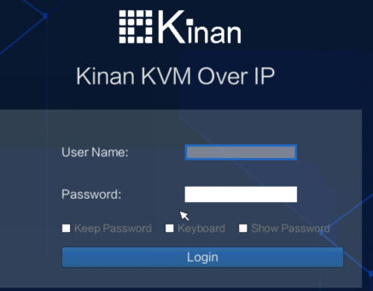
User Name: | admin
Password: | admin

- LED panel is powered on when the power LED is green.
- Power on the computer or server after power on the KVM.

2.5 Closing the console
- Close the LED display panel and the power automatically shut down.
- Push the release catch in the direction of the arrow; push the LED panel all the way in until it automatically locks up.
Diagram 2.5 unlocking the console

3. LED Operation

3.1 LED Functions

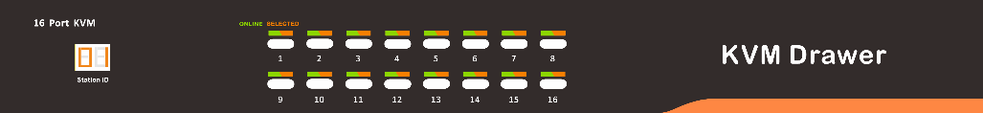
Figure 3.1 LED front views
No. | Components | Function
1 | 1-16 | Switching freely from port 1 to port 16
 | Reset | Press 【1】and 【2】 at the same time for three seconds resets the keyboard and mouse
 | Scan | Press【7】 and【8】at the same time for three seconds enters the auto scan mode.
 | Brightness  | Press【3】 for three seconds enters brightness adjusting mode.  33 are flashing on the LED tube.  Then press 【5】，【6】to adjust.  Press【3】exits or waits for five seconds and it will auto-exit.
 | Definition  | Press 【4】 for three seconds enters definition adjusting mode.  44 are flashing on the LED tube.  Then press 【5】，【6】to adjust.  Press 【4】 exits or waits for five seconds and it will auto-exit
 | Initialize  | Press 【6】 for three seconds will initialize the brightness and definition of each port.
2 | Port Selection  Buttons & LEDs | Indicator LEDs are built into the switches, the online LED light is on the left and the selected LED light is on the right.  - An online LED light (green) indicates that the KVM has connected to its corresponding computer and power on.  - A selected LED light (orange) indicates that the computer attached to its corresponding port is up and running.
3 | Station ID | Display the current port



Figure 3.2 32 Port LED front views
No. | Components | Function
1 | 0~9 +Enter | Switching from port 1 to port 32  Port 8 : If you want to switch to Port 8, press【8】, and the LED light displays 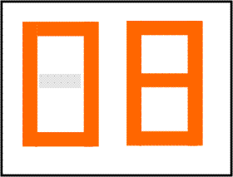, then press “Enter”, you will come to Port 8.  Port 32: If you want to switch to Port 32, press【3】and【2】, the LED light displays , and then press “Enter”, you will come to Port 32.
2 | (+, -) | Adjust Brightness  Press, the LED light blinking with, and then press “+” and “–“to adjust the brightness.
3 | (+, -) | Adjust Definition  Press , the LED light blinking with , and then press “+” and “-“to adjust the definition.
4 | Station ID | Display the current port

3.2 Operating the Monitor

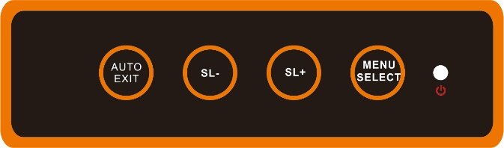
Figure 3.3 Monitor adjust menu buttons
The LED OSD allows you to set up and configure the LED display.

Buttons | Functions
MENU SELECT | Brings up the main menu.
EXIT/AUTO | Exits the current menu and returns to the previous menu or exits the LED OSD.  Press AUTO for automatic configuration.
SL-/SL+ | Moves the menu to make corresponding adjustment.
LED state | Green: Running  Red: Power off or access non standard VESA signal  Flashing green: Energy saving mode or no signal

Press AUTO if the screen migrates after power on or under other circumstances, then the screen auto-configures to its best display state.

Note:
- It may not be adjusted to its best state if part of the display mode is not standard VESA mode. if so, return back to OSD menu to RESET, then it will revert back to normal.
It is recommended to set up the display mode at 1920×1080, refresh rate at 60Hz.

3.3 Key Combination Function

If you want to set other hotkeys to pop up the UI interface or key combination switch, set up the via the local console, 【System Settings】> 【Device info】

Pop up the  UI interface | Double click【L_Ctrl】  Double click【L_Alt】  Double click【Scroll Lock 】  Double click【Caps Lock】
Hot key | 【L _Alt】 +【L_Ctrl】  【L_Win】+【L_Ctrl】  【L_Alt】 +【L_Win】

Hotkey commands are as follows：

Hot key + the corresponding function key

Function | Operating | Function description
Port switch | +Number | Skip ports from 1~16
 | + 【↑】/【→】 | Skip to previous port
 | + 【↓】/【←】 | Skip to next port
Brightness | +【+】 | +
 | +【-】 | -
definition | +【>】 | +
 | +【<】 | -
Reset Video | +【R】 | Reset the video
Lock KVM | + 【L】 | Lock KVM and a user login window appears

4. User Interface Operation

- login UI control menu

User Name | admin
Password | admin

After logging in the device, you can see the connection status of the device port.

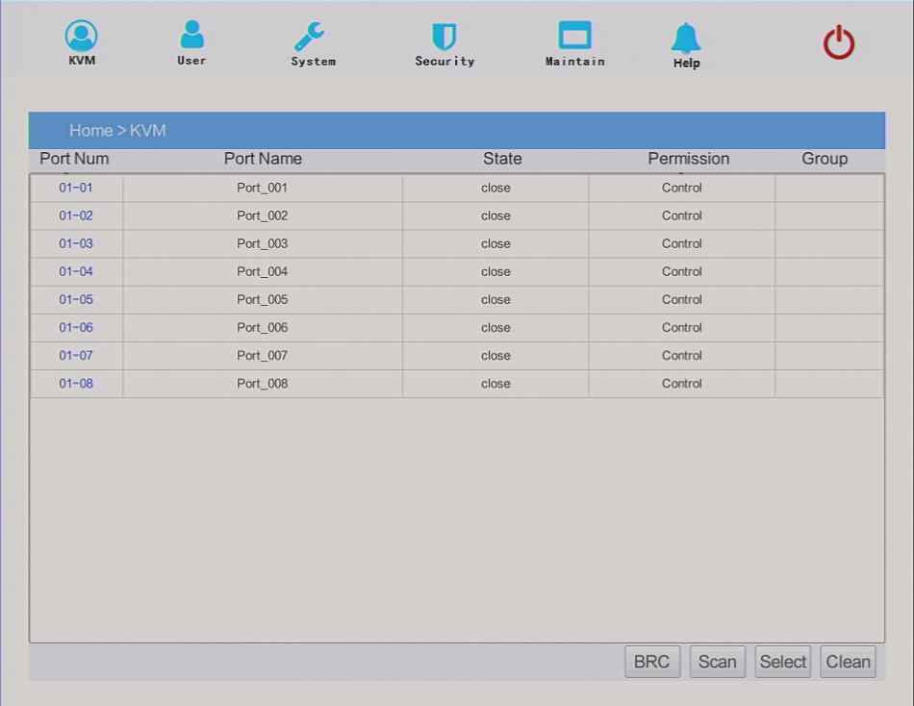

In the port list,
1. Click the “Connect" to enter the host screen;
2. In the host screen, press the [L_Ctrl] key on the keyboard twice.
Return to the UI interface.
3. Access status of the KVM ports
"connect" means that the user can access that port at any time
"close" indicates that the connected server/computer is not powered on
"uart" means the serial module is connected

4.1 User
User management mainly set up for adding, deleting and modifying user& user group, user password modification, user group permissions and so on. If the user do not have user management authority, the user cannot access to user management interface. The user in this section is who have the user management authority.

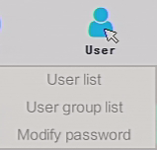

User List
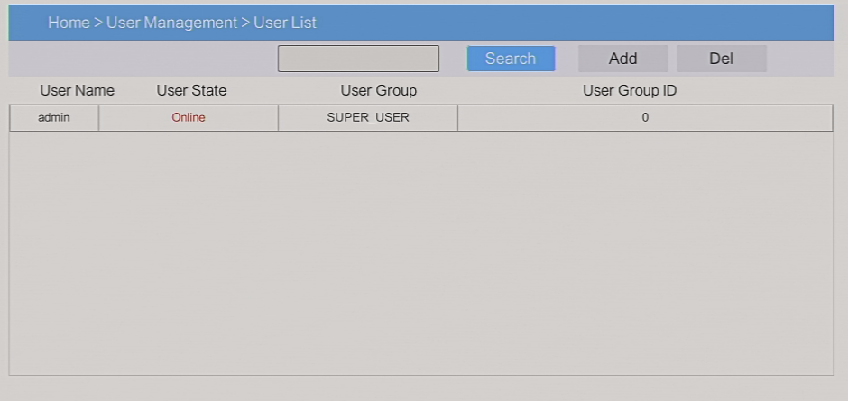

User list interface: list all registered users, you can see more by page turning
  - User name or full user name search
Input user name, it shows related users which make it convenient when you have a large number of users

  - Add user
Click【add】button, the window below appears:
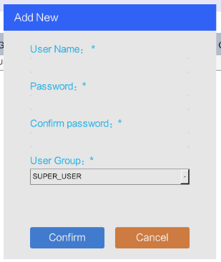

In this window, “*” is required content
- User name: user name can only be low case letter, number and “_”
- Enter password: without strong password protection, the password can only composed of 1-16 letters, numbers or special characters(-@.$! _); with strong password protection, the password should be filled in according to the rules of strong password protection. More details please check “security management—＞security setting—＞strong password”
- User group：Select the corresponding user group

User group list
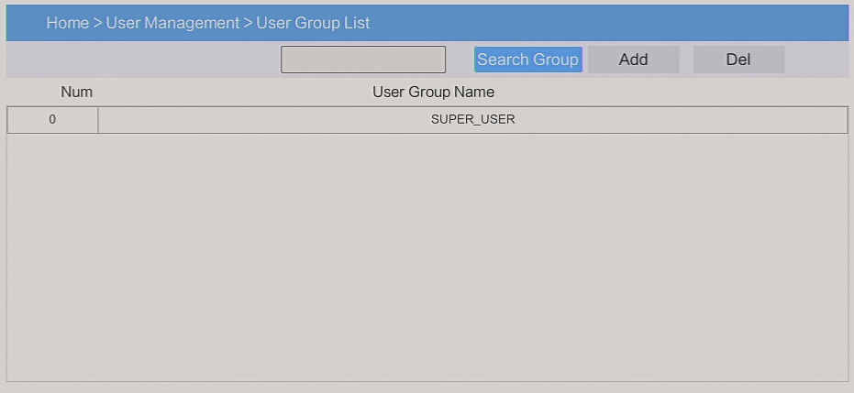
User group list interface：List all registered users, you can see more by page turning
  - User group name search
Input user group name, it shows related user groups which make it convenient when you have a large number of users
  - Add user group
Click【add】button, the window below appears
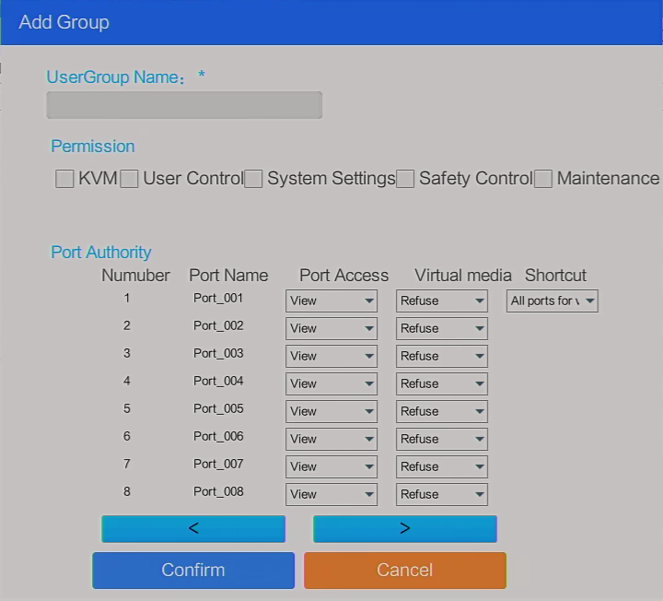

1) User group name: it contains only low case letter, number and “_”
2) Authority: mainly refers to management authority and operation authority, click show more, authority menu appears(shown in picture above), click show less, authority menu disappears
- Port Access: Authority to access KVM, and control target server
- User Management: user management authority
- Device Setting: KVM device management authority
- Security Management: security management authority
- System Maintenance: system maintenance authority
3) Port authority: set up access and operating authority for each port

Change password
Change the User login password.

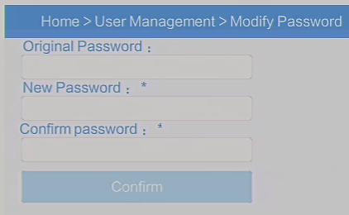

In this window, “*” is required content
- User name: it contains only low case letter, number and “_”
- Enter password: without strong password protection, the password can only composed of 1-16 letters, numbers or special characters(-@.$! _); with strong password protection, the password should be filled in according to the rules of strong password protection. More details please check “security management—＞security setting—＞strong password”
- User group: Select the corresponding user group

4.2 System
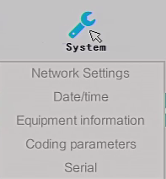

Network settings
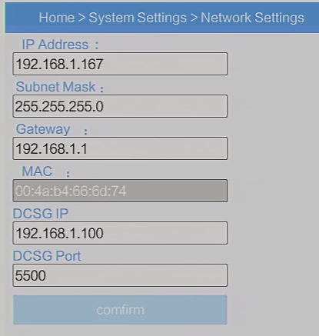
ＩＰｖ４address setting:
- ＩＰaddress: preset IP address
- Subnet mask: Generally, it should be consistent with other devices in
the network.
- Default gateway: Generally, it should be consistent with other devices in
the network.
- MAC address：physical address
- DCSG IP: the IP address should be the same with the Authentication Server
IP address
- DCSG Port: the Port should be the same with the Authentication Server Port.
.

Date time
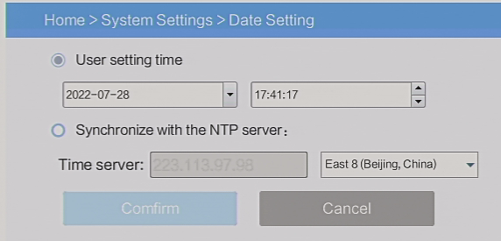
System time setting:
- Customized time: manual setting
- Synchronize with the NTP server: the system automatically updates the time according to the time

Equipment information
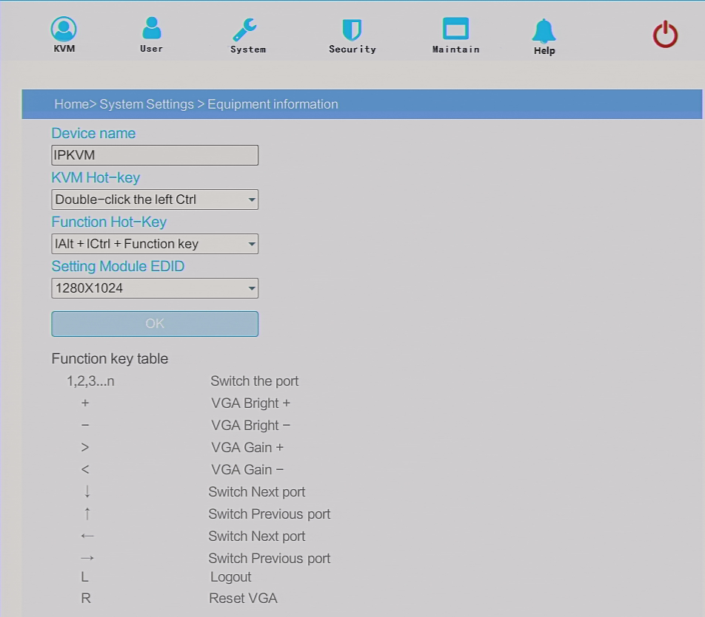

Encoding parameters

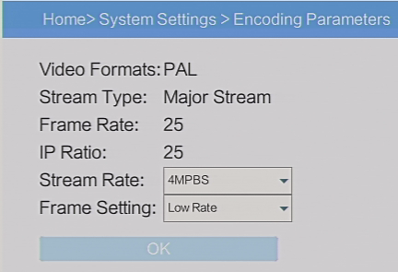

Serial
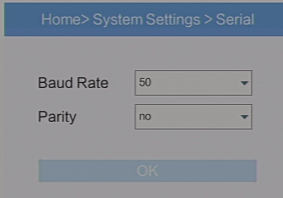
Baud Rate: Set the baud rate of the corresponding serial device
Parity: Set the check digit of the corresponding serial device

4.3 Security
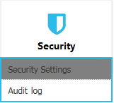

Security Settings
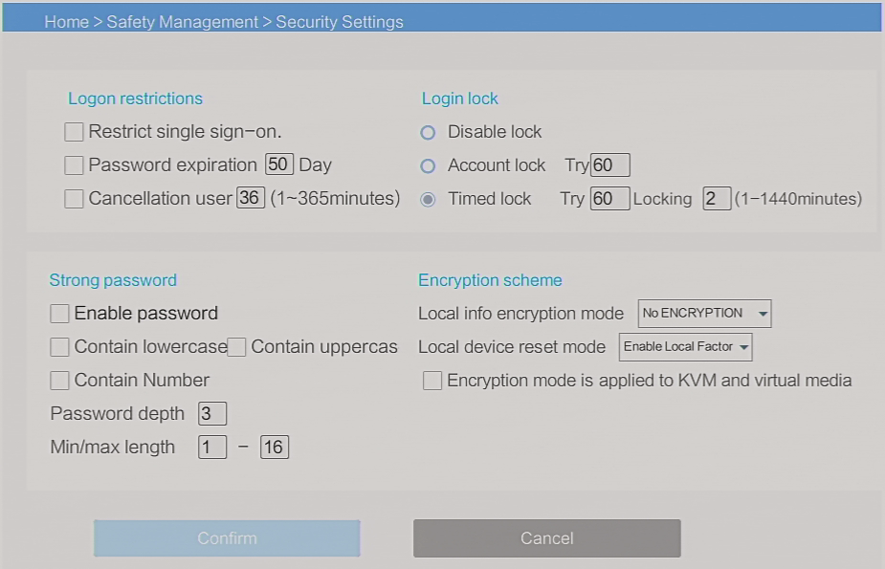

  - Login restriction: user name login restriction
- Single sign on restriction: if one user name is logged in, it can no longer log in with this user name, if it is selected, you can log in with the user name
- Enable passwords expiration: current password use days ranges from 1-365 days, if it is selected, the default is 50 days
- Free user log off: If user do not have operations after logging in a set time, the user will be logged off automatically
  - Login lock
- Disable Lock: when it is selected, login lock will be canceled
- Account lock: set trying number of times for login attempts failed
- Timed lock: set the account lock time when account login failed attempts are over the setting number of times
  - Strong password
- Enable strong password: when it is selected, the original password will be forced to be changed
- Password history depth: new password cannot be the same as the latest 3 default passwords, this number can be changed, it ranges from 1-10
- Strong password length: From 1 bit to16 bits.
  - Encryption mode
- Local information encryption mode: 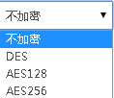three encryption schemes and one un-encryption scheme
- Encryption mode is applied to KVM and virtual media: applied when it is selected

Audit log

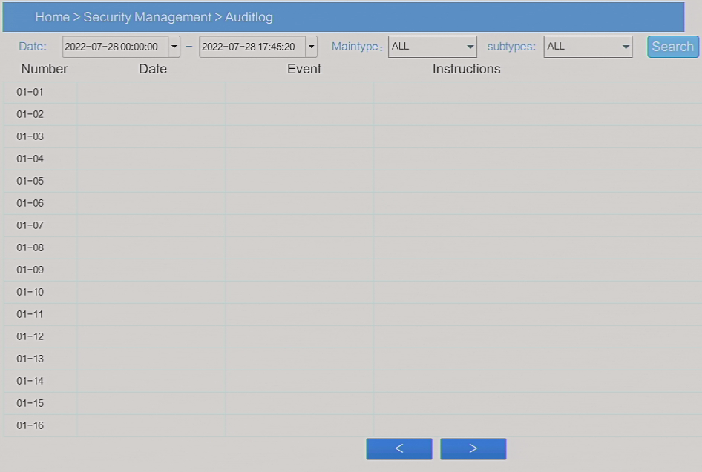

4.4 Maintain
Provide system maintenance tools such as test tools, data backup and restart
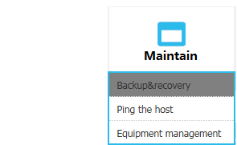

Backup& Restore
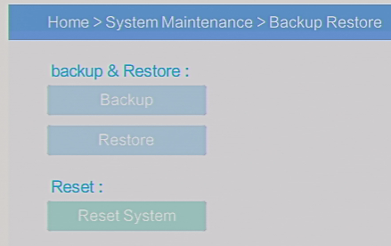
Backup: backup current system settings
Restore: restore the last backup of system
Factory reset: Restore to factory state (KVM must be restarted to take effect)

Ping
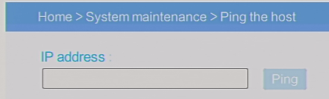

Update
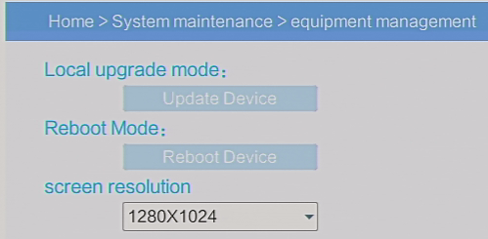

5.Remote control

5.1 Configure the target server
The KVM target server is the server that connected to the IP KVM Switch. Before install and use the IP KVM Switch, we need to configure the target server first. Please refer to below configuration instructions:
- The IP KVM switch supports below two mouse mode:
- Absolute mouse mode
- Relative mouse
- Intelligent mouse mode
Mouse configuration is different for different operating systems; please refer to below detail instructions for mouse configuration.
- Mouse and display configuration on Windows server 2003 and above version, Windows XP and above version
Operating systems: Windows server 2003, Windows server 2005, Windows server 2008, Windows server 2012; Windows XP, Windows7, Windows8, Windows10
- Set Mouse Precision
Start—>Control Panel—> [Hardware]—>Mouse

Please follow the steps above to finish the setting.

- Set up the display of the target server under Windows XP, Windows 2003, Windows2008
Start—>Control Panel—> [Hardware]—>Display

Please follow the steps above to finish the setting.

- Configure the mouse under Linux (ubuntu 10)

Input “xset m 1 1” in the Linux command line terminal and press Enter to finish the mouse setting, as shown below.

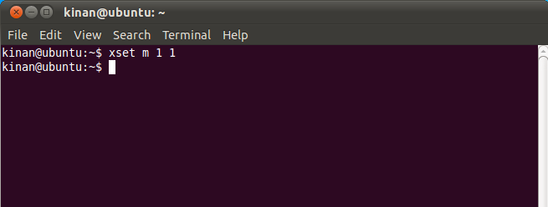

5.2 Remote WEB interface settings
Install and open IE browser, click top-right settings→【Internet Options】
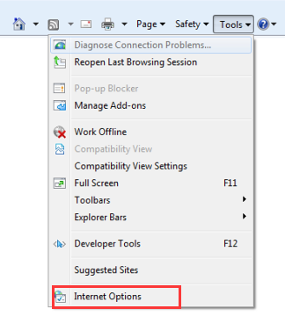
Click【Security】→【Custom Level】
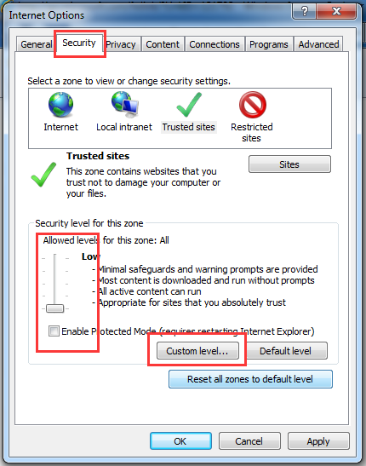

Select【ActiveX controls and plugins】, enable all the controls and plugins, if Enable is not safe, select Prompt.
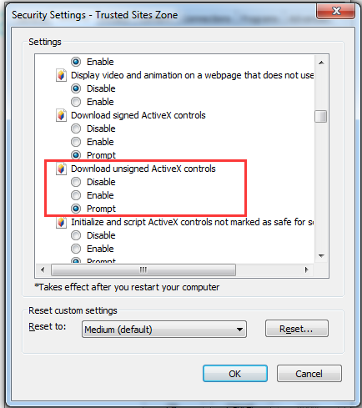

Set the local intranet and trusted sites as above

Click【Advanced】, find 【Allow software to run or install even if the signature is invalid】and select it.

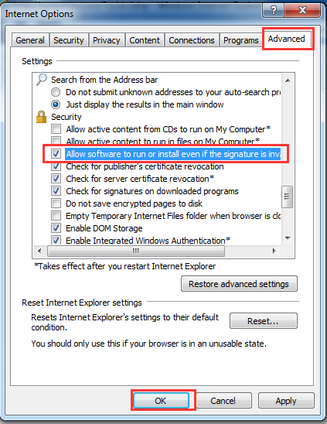

5.3 Log in

Default Items | Default Value
User name | admin
Password | admin
IP address | 192.168.1.167
Notice: For security, please change the password after the first login
Differentiating between capital and lowercase letters.

After connecting the device, open the Internet explorer web browser:
http:// 192.168.1.167
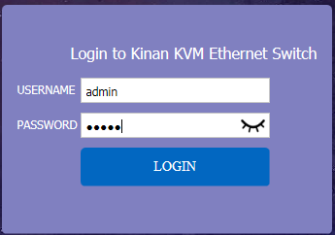

User Name: admin
Password: admin

After logging in for the first time, a prompt for loading the ActiveX will appear below the browser. Clicking “Allow” will bring up the Download Video Plugin dialog box. Click “OK” to use the video plugin.

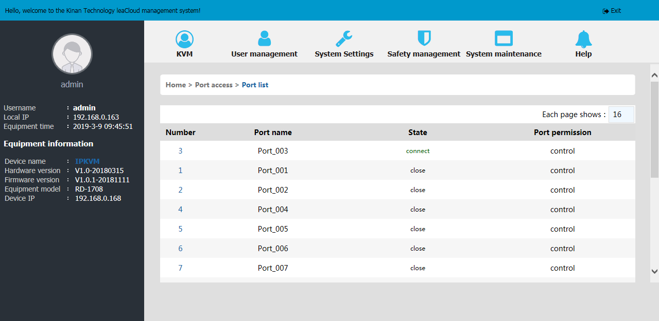

Access status of the KVM ports, three connection status:
1.busy, 2. Connect , 3. close
- “Connect” shows the target KVM is connected to the KVM port; users can access to the target anytime.
- “close” shows that the KVM is not connected to the KVM adapter or the target server, or the target server is not boot up.
- “busy” shows that port is access by local or remote users.

Edit Port Name:
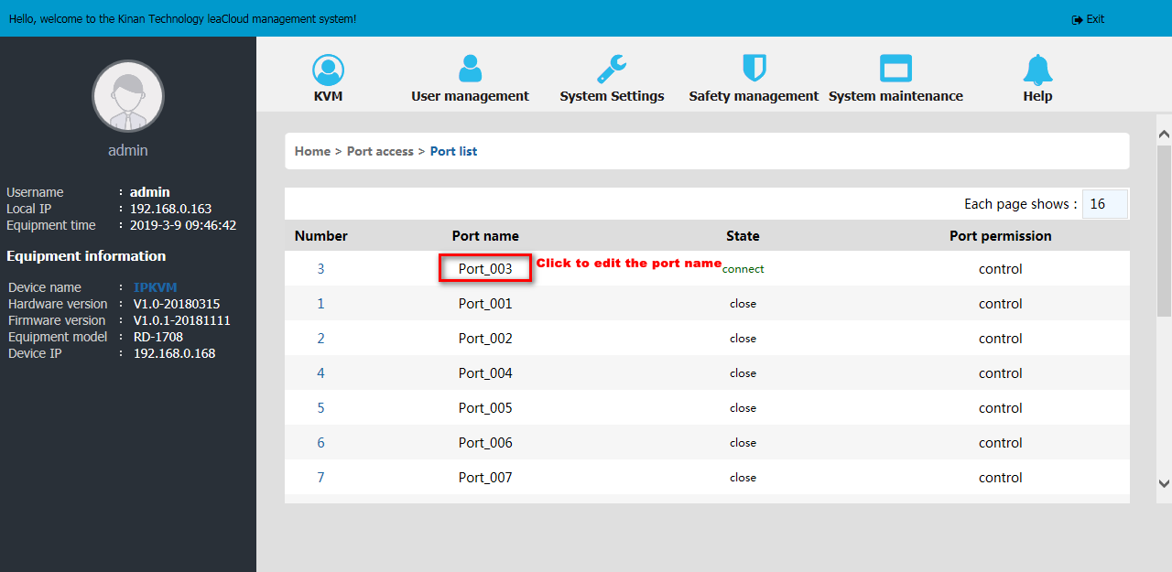

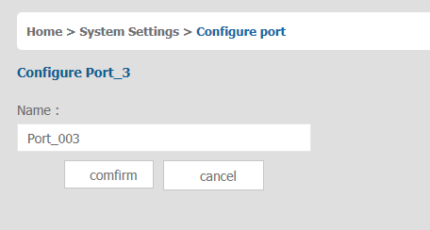

Video Control Interface Menu



【Hide or Show Toolbar】
【Setting Option】
【Send Ctrl+Alt+Del】
【Mouse Synchronization】
【Single Mouse】
【Adaptive Window】
【Source Video params】
【Full Screen】

1）Hide or Show Toolbar 
When the video window starts, the toolbar is always displayed by default.
Click the icon, the toolbar will automatically hide. When the mouse move out (into) from the toolbar, it hides shows).
2）Setting Options
2.1 Keyboard & Mouse Options
When user has the authority (chart 5-1.1)

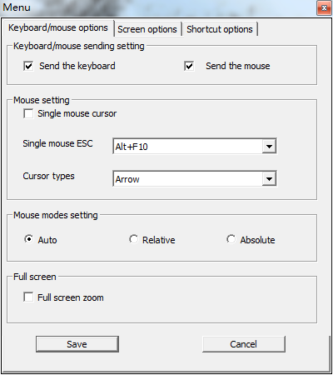
Chart 5-1.1

- Keyboard/mouse sending setting
  - Send the keyboard: keyboard data can be sent to the target server through the video window so that it can control the target server’s keyboard.
  - Send the mouse: mouse data can be sent to the target server through the video window so that it can control the target server’s mouse.
- Mouse Setting
  - Single mouse cursor: when single mouse chosen, target server’s mouse will show and remote user’s mouse will hide
  - Single mouse ESC: press the keyboard “Alt + F10” exit the single mouse mode.

  - Cursor types: it can set remote user’s mouse cursor type in double mouse mode
- Mouse Mode Setting:
  - Relative mode: Relative mode is compatible with almost all the operating systems, the factory default mode is relative mode.
  - Absolute mode: The absolute mode is not compatible with LINUX operating system.
- Full Screen Setting
  - Full Screen Zoom: If the “Full Screen Zoom” is disabled, the video will be displayed in the remote full screen; If the “Full Screen Zoom” is enabled and the target server’s resolution is different from the remote user computer’s resolution (the resolution of the general target server is less than the resolution of the remote user computer), the video plug-in will display the screen in the middle of the screen according to the resolution of the target server.

When users only have authority to view, remote users can only view the video window and cannot control it, as shown in Chart 5-1.2.
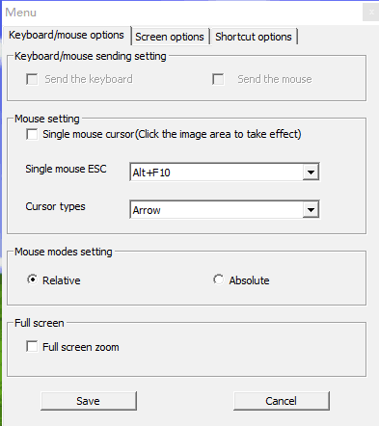
Chart 5-1.2

  - Display option
Display option dialogue shows screen parameters and screen information, as shown in 2-3
- Frame Parameter
  - Automatic calibration: The video window will automatically adjust the screen parameters of the target server to the default best effect.
  - Contrast, brightness, hue and saturation: if “automatic calibration” is disabled, users can customized screen parameters of target server.
- Frame information
  - Resolution: it shows the resolution of the target server. When the target server’s platform is win10, it shows the resolution of video
  - IP address: KVM switch’s IP address
  - Refresh Rate: video refresh rate
  - Port number: video port number
  - Manual calibration resolution: when the resolution of the target server is not consistent with the resolution of the video window, it can manually calibrate the resolution after calibration
  - Target server resolution: resolution selection of manual calibration
  - Target server’s picture zooming: Under the win10 system, if the resolution is not the best resolution, the win10 system will zoom the video screen, and the video window cannot automatically identify whether the video source picture is zooming or not, then the user need to select the option by its own.
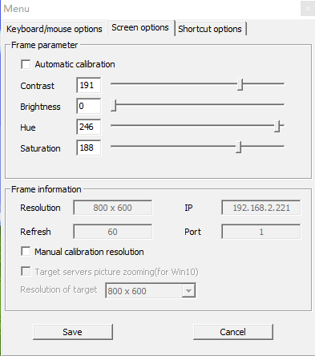

Chart 5-1.3

2.3 Keyboard Shortcuts
Support 11 keyboard shortcuts, each with a maximum of 6 keys.
It can save shortcut keys and can be directly used when logging in next time. Shown as chart 5-1.4
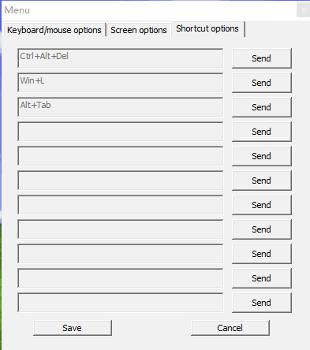
Chart 5-1.4
Click blank input box, virtual keyboards appears, and then key clicked on the virtual
keyboard will be displayed in the input box.
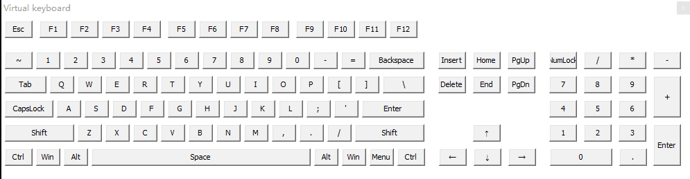
3）Send ------send Ctrl+Alt+Del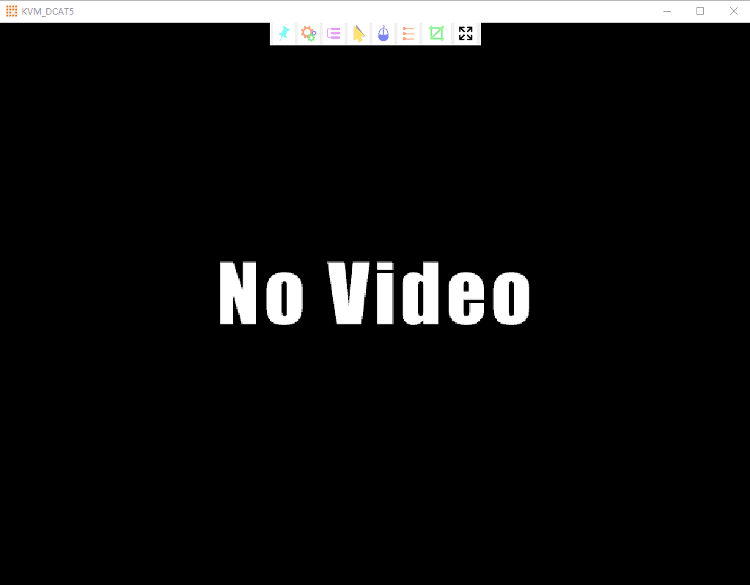
Keyboard Macro: click this button, the target server will receive shortcut key.
- Send Ctrl+Alt+Del
Bring up the task manager of target server (Windows operating system)
4）Mouse Synchronization
In double mouse mode, click this button to automatically collate the current mouse, and synchronize the external mouse and internal mouse to the origin of the left corner of the video window.

5）Single mouse
In the video window, it will hide the remote user’s mouse, and only show the target server’s mouse.
6) Source video params

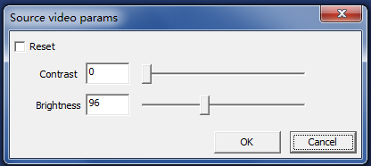

7) Optimum size
The initial size of the video window is 1024x768, when click this button, the video window will adjust the size of the window according to the resolution of the target server.

8）Full Screen
The video window enter full screen mode

6. IP Menu Option

6.1 User management
User management mainly set up for adding, deleting and modifying user& user group, user name password modification, user group permissions and so on. If the user do not have user management authority, the user cannot access to user management interface. The user in this section is who have the user management authority.
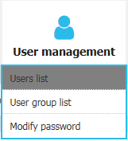

User List

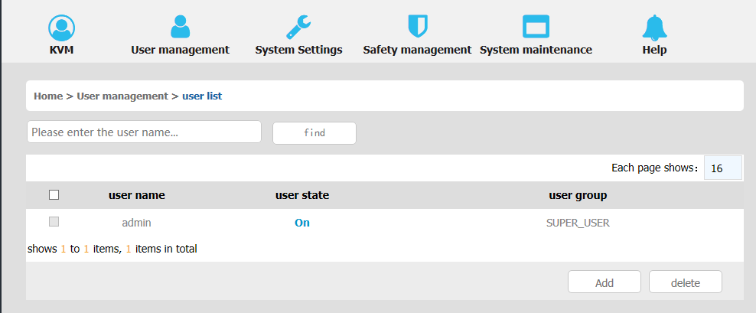

User list interface: list all registered users, you can see more by page turning
  - User name or full user name search
Input user name, it shows related users which make it convenient when you have a large number of users

  - Add User
Click【add】button, the window below appears:
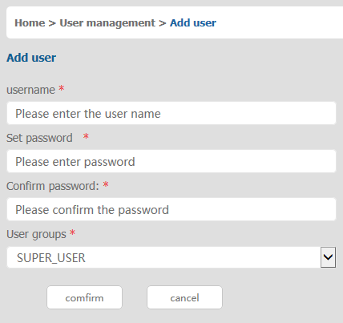
In this window, “*” is required content
1) User name: user name contains only low case letter, number and “_”
2) Enter password: without strong password protection, the password can only composed of 1-16 letters, numbers or special characters(-@.$! _); with strong password protection, the password should be filled in according to the rules of strong password protection. More details please check “security management—＞security setting—＞strong password”
3) User group: Select the corresponding user group

  - Delete User
Select the user you want to delete, click 【delete】,
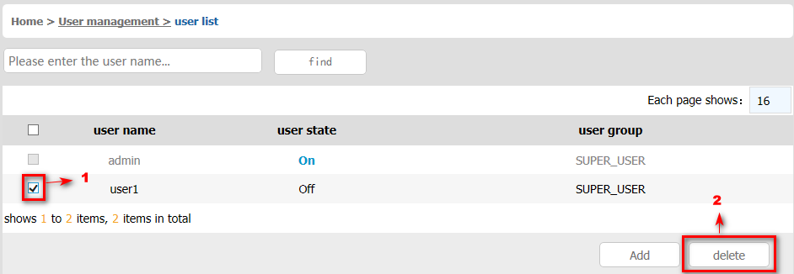
Note：admin cannot be deleted，other users can be deleted, even if they are online.

  - Edit user

Click【A1】, edit user window pop up
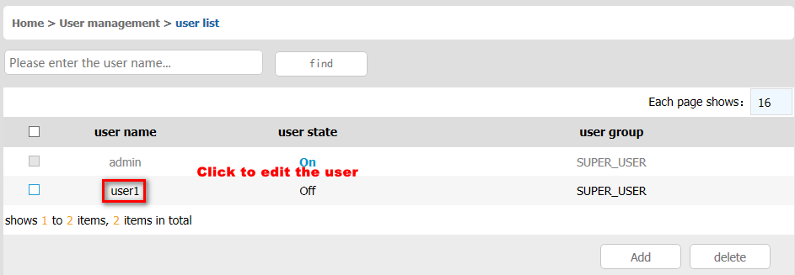

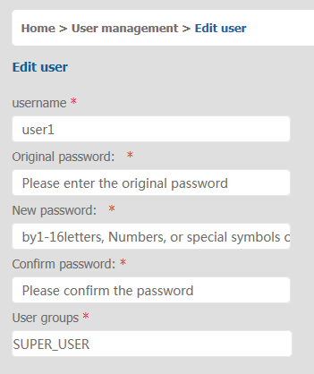

User group list

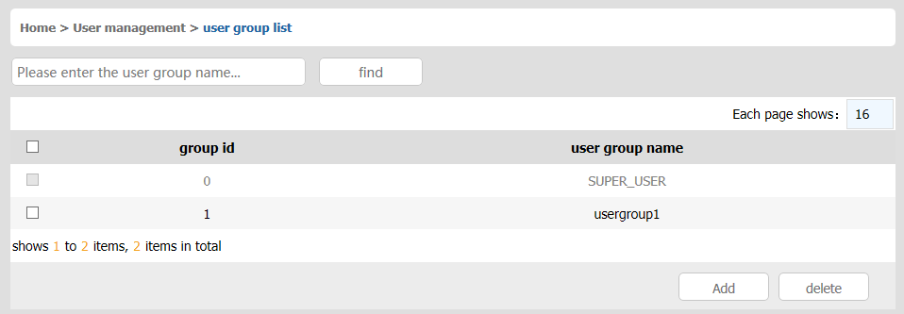

User group list interface: list all registered users, you can see more by page turning
  - User group name search
Input user group name, it shows related user groups which make it convenient when you have a large number of users
  - Add user group
Click【add】button, the window below appears

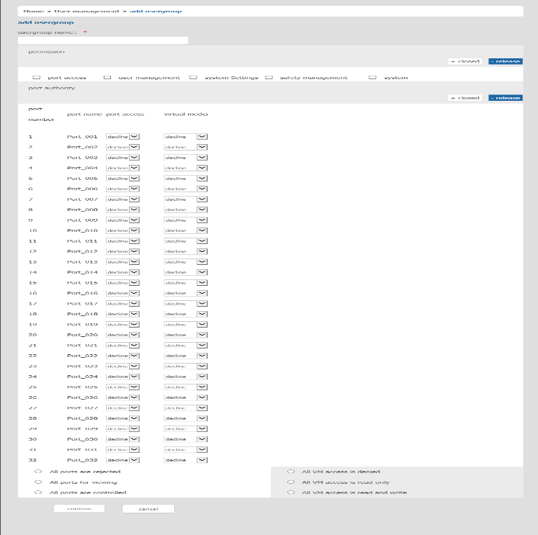

1) User group name: it only contains low case letter, number and “_”
2) Authority: mainly refers to management authority and operation authority, click show more, authority menu appears(shown in picture above), click show less, authority menu disappears
- Port Access: Authority to access KVM, and control target server
- User Management: user management authority
- Device Setting: KVM device management authority
- Security Management: security management authority
- System Maintenance: system maintenance authority
3) Port authority: Set up access and operating authority for each port

  - Delete user group
Select the user group you want to delete, click【delete】

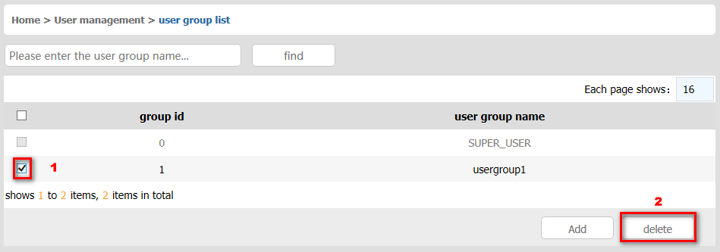
Note：SUPER_USER is system allocated which cannot be deleted
  - Edit user group
Click【1】edit user group window pop up ; For specific operation, please check “add user group”

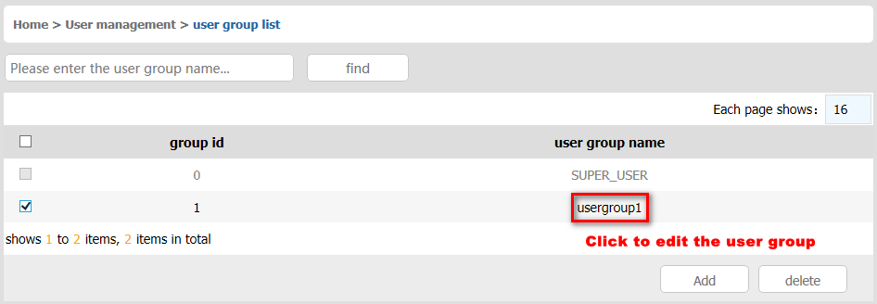

Change Password
The passwords which is using for logged user
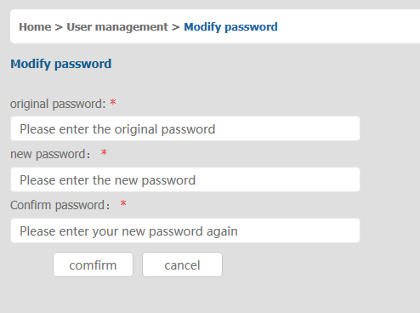
1）Old passwords: The passwords you are using
2）New passwords: Without strong password protection, the password can only compose of 1-16 letters, numbers or special characters (-@.$! _); with strong password protection, the password should be filled in according to the rules of strong password protection. More details please check “security management—＞security setting—＞strong password”

6.2 System

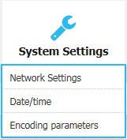

Network Setting
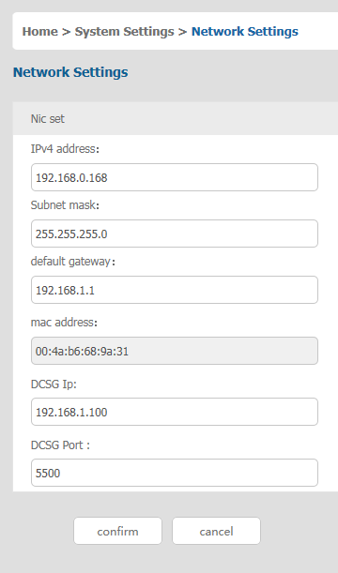

ＩＰｖ４address setting:
- ＩＰaddress: preset IP address
- Subnet mask: Generally, it should be consistent with other devices in the network.
- Default gateway: Generally, it should be consistent with other devices in the network.
- MAC address: physical address
- DCSG IP: the IP address should be the same with the Authentication Server IP address
- DCSG Port: the Port should be the same with the Authentication Server Port.
.

Date /Time setting
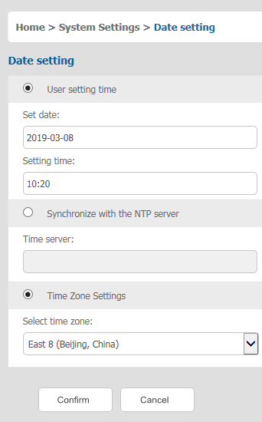

System time setting:
- Customized time: manual setting
- Synchronize with the NTP server: the system automatically updates the time according to the time server
- Time zone setting: choose time zone

Encoding Parameters

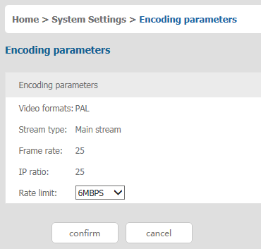

6.3 Safety management

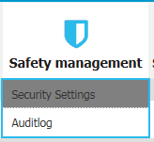

Security Settings
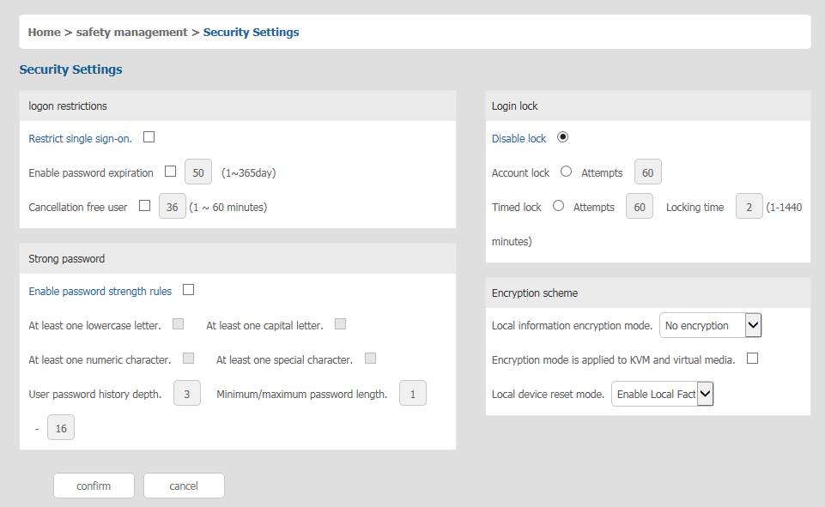
  - Login restriction: user name login restriction
- Single sign on restriction: if one user name is logged in, it can no longer log in with this user name, if it is selected, you can log in with the user name
- Enable passwords expiration: current password use days ranges from 1-365 days, if it is selected, the default is 50 days
- Free user log off: If user do not have operations after logging in a set time, the user will be logged off automatically
  - Login lock
- Disable Lock: when it is selected, login lock will be canceled
- Account lock: set trying number of times for login attempts failed
- Timed lock: set the account lock time when account login failed attempts are over the setting number of times

  - Strong password
- Enable strong password: when it is selected, the original password will be forced to be changed
- Password history depth: new password cannot be the same as the latest 3 default passwords, this number can be changed, it ranges from 1-10
- Strong password length: From 1 bit to16 bits.

  - Encryption mode
- Local information encryption mode: three encryption schemes and one un-encryption scheme
- Encryption mode is applied to KVM and virtual media: applied when it is selected

Audit Log

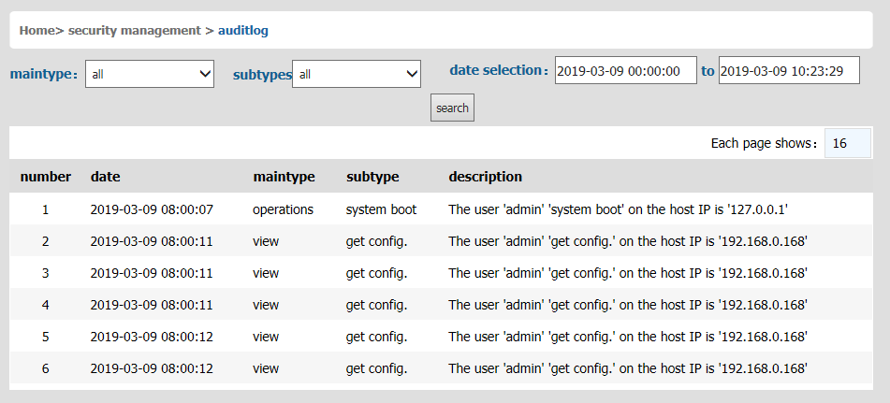

6.4 System Maintenance
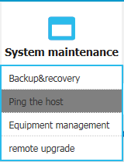

Provide system maintenance tools such as test tools, data backup and restart

Backup& Restore
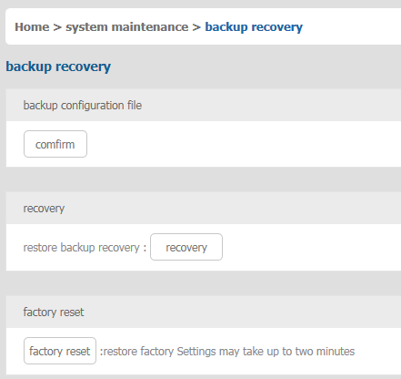

- Backup :backup current system settings
- Restore: restore the last backup of system
- Factory reset: Restore to factory state (KVM must be restarted to take effect)

Ping Host
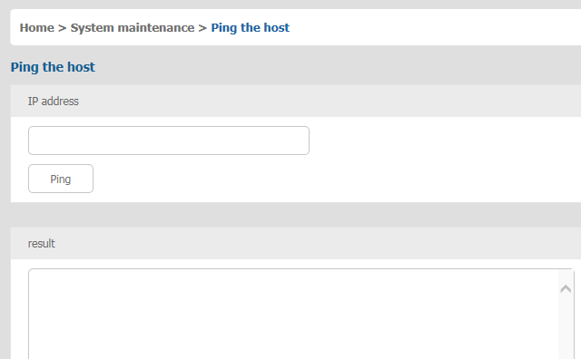
- Test network connection state to target server
Input IP address and click【ping】 button , if network is smooth, result returns to “ip is active”; If not, it returns to “no response from IP” (IP is tested target server’s IP).

Equipment Management

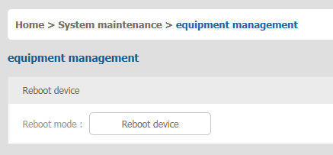

Remote upgrade

Provide users with better upgrade experience and continuous technical support

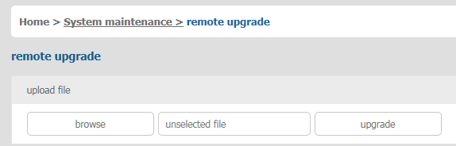

Upgrade method:
Click【browse】 and select upgrade file, upload the file to the device, then click【upgrade】to finish upgrade

7.Appendix

7.1 Specifications (17.3”)
Model |  | HT2708 | HT2716 |  | HT2724 | HT2732
Computer Connections | Direct | 8 | 16 |  | 24 | 32
 | Max | 8 | 16 |  | 24 | 32
Port Selection | Keyboard, Mouse | Button, UI, Web, Hotkey
LED Monitor | Model | FHD TFT
 | View Area | 17.3"
 | Optimum Resolution | 1920×1080@60Hz
 | Color | 16.7M
 | Brightness | 250cd/m²( T y p )
 | Contrast Ratio | 800 : 1( T y p )
 | Pixel Pitch(mm) | 0.1989(H) × 0.1989(W)
Mouse | X/Y Resolution | >1000 points / inch, (40 points/mm)
 | Scroll Wheel | Supports Scroll Wheel function
Keyboard |  | 99 keys (82 keyboard + 17 number pad)
Remote | Remote Control | KVM Control (ActiveX)
 | Management | Web
 | Security | DES Encrypted
 | Resolution | 1920×1080@60Hz
Power Input |  | 100V- 240Vac , 50-60Hz , <1.5A
Mounting distance |  | 510-850mm ( L=420mm)  Mounting bracket can be customized for  Other mounting distance
Power Consumption |  | 23W |  | 25W | 27W | 29W
Operating Temperature |  | 0 — 50 ℃
Store Temperature |  | -20 —60 ℃
Humidity |  | 0—80% RH, non-condensing
Net Weight |  | 11.2kg |  | 11.2kg | 11.4kg | 11.4kg
Product Dimension (W × D × H) |  | 448mm×525.6mm mm×42.5mm
Package Dimension (W × D × H) |  | 765mm×615mm×185mm

7.3 Grounding Requirements
Make sure the KVM and the devices that connected to KVM are all connected to the ground.

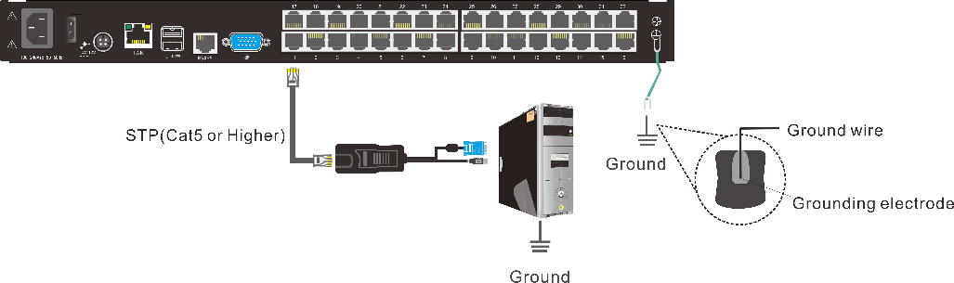

To improve the device safety, please make sure the device is connected to the ground and use the STP cable to connect the device.
The STP cable contains four shielded twisted pair and one ground wire, the ground wire should be welded into the RJ-45 connector.

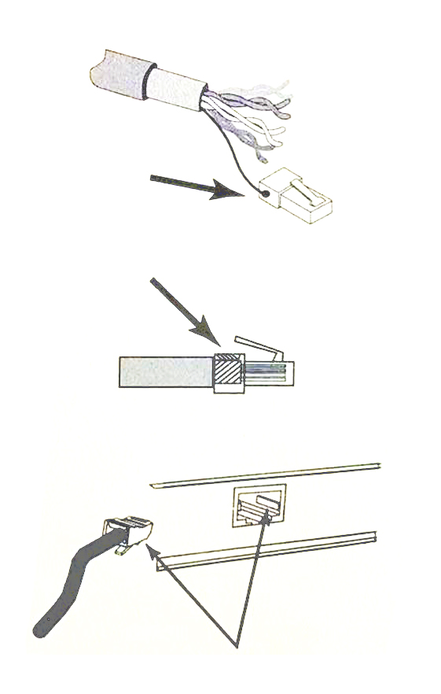
Grounding the STP shield cable (as shown below) , and make sure the metal RJ45 connector is tight shield.
Connect one end of the RJ-45 connector to the ground RJ-45 connection socket.

